Date: | February 7, 2023
To: | Don Morehouse, ODOT Region 4  Scott Woodford, City of Sisters
From: | Joe Bessman, PE
Project Reference No.: | 1237
Project Name: | Sisters Multifamily Housing Zone Change/Text Amendment
This memorandum outlines the potential land use and transportation implications of a Comprehensive Plan Amendment and Zone Change impacting seven parcels located along N Trinity Way from Urban Area Reserve (UAR) to a mix of Public Facilities/Institutional (PF/I) and Multi-Family Residential (MFR), along with various text amendments to support City housing goals.
The City-initiated rezone process is intended to rezone the properties to a zone district that is more characteristic of their urban location, to permit the existing uses to continue, and potentially allow the properties (which are located within the Urban Growth Boundary and City Limits) to develop to urban densities. The parcels impacted by this land use action are outlined in Figure 1, with details on these parcels summarized in Table 1.
Table 1. Summary of Impacted Parcels
Map ID  (See Figure 1) | Map Taxlot | Address | Acres | DIAL Ownership
1 | 151005CD00900 | 1307 W McKinney Butte Rd | 3.30 | Sisters Community Church
2 | 151005CD00800 | 452 N Trinity Way | 2.50 | Corp Pres Bishop Church of Jesus Christ of LDS
3 | 151005CD00700 | 123 N Trinity Way | 8.19 | St Edward Catholic  Church of Sisters
4 | 151005CD00200 | 442 N Trinity Way | 2.72 | International Church of the Foursquare Gospel
5 | 151005CD00300 | 322 N Trinity Way | 2.97 | International Church of the Foursquare Gospel
6 | 151005CD00400 | 222 N Trinity Way | 2.63 | Assemblies of God  Oregon District
7 | 151005CD00500 | 121 N Brooks Camp Road | 5.01 | Bishop of the Protestant Episcopal Church in the USA in the Episcopal Diocese of Eastern Oregon
Total |  |  | 27.32
To date, City of Sisters planning staff has been in discussions with the property owners and representatives to discuss these opportunities. The overall changes will continue to allow the church properties as conditional uses within the PF/I and MFR zone districts. This will still provide the opportunity for the churches to be renovated, expanded, or otherwise altered to better suit their needs, while also permitting some level of residential, public facilities, or institutional uses within this area to support the City’s housing needs.
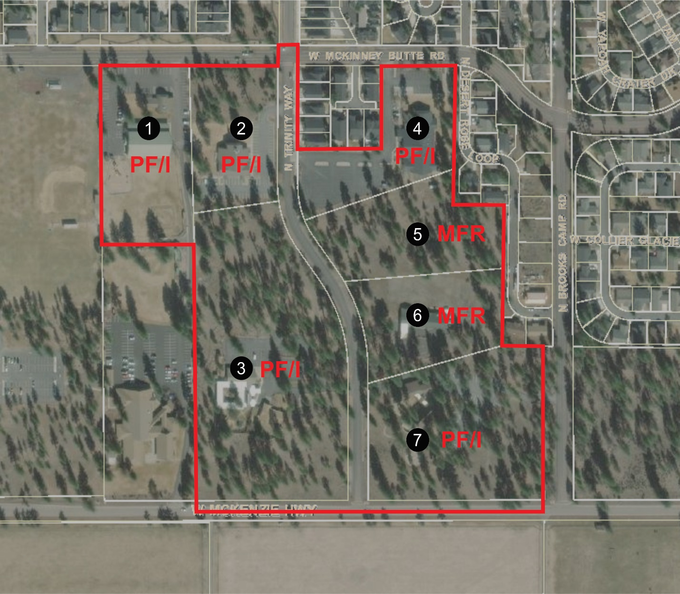Figure 1. Proposed legislative rezone boundary.

Transportation Planning Rule Criteria
In order to rezone the subject property from Urban Area Reserve to PF/I or MFR the application will need to show compliance with the Transportation Planning Rule section on Plan and Land Use Regulation Amendments (OAR 660-012-0060). Effectively, the purpose is to show that changes in land use will continue to be supported with safe, accessible, and efficient multimodal transportation systems. This process also ensures that changes to land use do not impact the findings and funding mechanisms outlined within the City’s adopted Transportation System Plan, and thereby conforms with the State’s planning requirements.
OAR 660‐012‐0060(1) and (2) establish a two-step process for evaluating an amendment’s impact on transportation facilities, typically by comparing the land use assumptions for the property that served as the basis for the Transportation System Plan. The first step in a legislative or quasi-judicial rezone process is to compare the trip generation potential of the property assuming a “reasonable worst‐case” development scenario under the existing and proposed zoning. If the trip generation potential increases under the proposed zoning, additional operational analysis may be required to assess whether the rezone will “significantly affect” the transportation system. Conversely, if the trip generation under the proposed zoning is equal to or less than that under the existing zoning, no additional operational analysis is necessary to conclude that the proposal does not significantly affect the transportation system. A comparison between trip generation associated with the existing and proposed zoning scenarios is presented below.

Existing Urban Area Reserve (UAR) District
Per Chapter 2.9 of the City of Sisters Development Code, the existing UAR designation on the subject property is intended to “to serve as a holding zone for lands that are within the Sisters Urban Growth Boundary and within City jurisdiction and to retain parcels in larger sizes until public facilities (including water, sewer and transportation) are available and the land is rezoned for urban uses and densities.” This zoning district allows the following uses outright:
- Single family detached dwellings
- Manufactured home on individual lot
- Childcare Home
- Open space and parks
Within this zoning designation existing churches and places of worship in place at the time of adoption of the development code are considered conditionally permitted and conforming uses. This would not allow new churches to be constructed on undeveloped parcels.
The following development standards also pertain to the UAR zone:
- 2.5-acre minimum lot size within City limits
- 50-foot front yard setback if abutting an arterial or collector (such as Trinity Way, McKinney Butte Road, Brooks Camp Road [Neighborhood Route] or Highway 242)
- 20-foot front yard setback if abutting a local street
- Building height limit of 30 feet, with exceptions for bell towers and other non-occupied appurtenances.
With these acreage limitations and the limited types of allowed uses there is very limited development potential within the subject parcels today. In terms of a “worst-case trip generation scenario” the most intense allowable use would be the expansion of the existing churches, which could potentially include some type of daycare and school uses. For purposes of this review, it was assumed that the undeveloped acreage could include 10% coverage with new buildings and structures associated with church or supportive school/daycare uses, with a 200-student private school included within this land.

Proposed Public and Institutional Facilities District
The proposed Comprehensive Plan Amendment and rezone of approximately 21.72 acres will be to Public Facilities/Institutional District (PF/I). The general purpose of this zoning district is described within SDC 2.7.100 as follows:
The Public Facility (PF) District is intended to provide areas primarily for the location and establishment of facilities which are maintained in public and quasi-public ownership and which utilize relatively large areas of land.
In addition to the text amendments, the PF/I zoning district allows a wide variety of public uses outright, including, libraries, museums, parks, and schools.
The following development standards also pertain to the PF zone:
- Front yard setback of 10 feet (unless abutting a residential zone)
- 35-foot maximum height
- No minimum setback if bordering a non-residential zone, 20-foot setback adjacent to residential
This zone would allow substantially higher levels of development to occur within these parcels than the current holding zone. A reasonable maximum development scenario would be for the undeveloped portions of the parcels to redevelop with civic or multifamily uses. Assuming that any current structures remain in their existing locations, the developable areas within each of the parcels are summarized below. This table also shows the building area for civic (based on a typical Floor to Area Ratio, or FAR, of 0.25) or residential density (assuming 15 units per acre).
Table 2. Summary of Maximum PF/I Redevelopment Potential
Map ID  (See Figure 1) | Potential Developable Acres | Typical Floor to Area (FAR) Ratio or Density
1 | 1.4 | 15,246 SF
2 | 0.93 | 10,128 SF
3 | 5.22 | 56,845 SF
4 | 0.69 | 7,514 SF
7 | 2.51 | 27,333 SF
Total | 10.75 Acres | 117,066 SF
Table 2 shows that about 117,000 square-feet of civic uses could be constructed throughout these parcels if the undeveloped portion of each lot were redeveloped to its maximum potential. Full build-out with this size of public facilities, however, would not be reasonable, as the City is not large enough to support this amount of additional public/governmental facilities. In addition, the shape of the parcels would limit the development potential of some of these areas for this type of use (or their associated parking and access), and more land-intensive uses (such as schools) would be difficult to construct within the dispersed acreages. Any schools or daycare facilities would be smaller in scale and likely associated with the existing church use. If the area were developed with public facilities, these would be comprised of several separate uses and would most likely provide office and administrative-related rather than public functions.

Proposed Multi-Family Residential (MFR) District
The proposed Comprehensive Plan Amendment and rezone of approximately 5.60 acres will be to Multi-Family Residential (MFR). The general purpose of the MFR zone is described within SDC 2.3.100 as follows:
The Multi-Family Residential District is intended to accommodate a range of housing types and lot sizes and to make efficient use of land and public facilities by establishing minimum and maximum density standards for housing. Multi-Family Residential District design standards ensure compatible building and site design at an appropriate neighborhood scale.
When the City’s Transportation System Plan was approved the MFR zoning district allowed a density range between 7 and 15 units per gross acre, with up to 20 units per acre allowed via Minor Conditional Use. This was recently modified to allow a density of 15 to 30 units outright, up to 40 units per acre conditionally, and up to 50 units per acre with affordable housing. Permitted uses also include family childcare in addition to a variety of housing types including single-family detached homes, duplex and triplex dwellings, multi-family development, and cottage homes.
The following development standards also pertain to the MFR zone:
- Front yard setback of 10 feet (unless it’s a front-loaded street accessed garage)
- 35-foot maximum height for all uses except for 5 or more attached multifamily units
- Attached multifamily units with 5 or more units have a maximum height for habitable area of 35 feet. Thirty-five to 50 feet may include non-habitable area.
This zone would allow substantially higher levels of development to occur within these parcels than the current holding zone. A reasonable maximum development scenario would be for the buildable portions of the properties to develop with multifamily uses. Assuming that any current structures will remain in their existing location, the developable areas within each of the parcels are summarized below. This table also shows the building area for residential density (assuming the maximum outright density of 30 units per acre).
Table 3. Summary of Maximum Redevelopment Potential
Map ID  (See Figure 1) | Potential Developable Acres | Typical Floor to Area (FAR) Ratio or Density
5 | 2.97 | 89 Units
6 | 1.75 | 52 Units
Total | 4.72 Acres | 141 units
Development at this density would serve as a higher-density use than any other residential project in Sisters; most three-story walk-up apartments (“Garden Apartments”) development at 20 to 22 units per acre. Development at this density would likely require some type of structured/tuck under parking configuration or a four-story building.

Trip Generation Comparison
Based on the land use scenarios, trip generation rates were compared based on the most current edition of the Institute of Transportation Engineers’ (ITE) standard reference Trip Generation, 11th Edition. The land use categories relevant to this review are described within the ITE as follows:
- Land Use 560 – Church: A church is a building in which public worship services are held. A church houses an assembly hall or sanctuary. It may also house meeting rooms, classrooms, and, occasionally, dining, catering, or event facilities.
- Land Use 730 – Government Office Building: A government office building is an individual building containing either the entire function or simply one agency of a city, county, state, federal, or other governmental unit.
- Land Use 715 – Single-Tenant Office Building: A single tenant office building generally contains offices, meeting rooms, and space for file storage and data processing of a single business or company and possibly other service functions including a restaurant or cafeteria.
- Land Use 220 – Multifamily Housing (Mid-Rise): Mid-rise multifamily housing includes apartments and condominiums located in a building that has between four and 10 floors of living space. Access to individual dwelling units is through an outside building entrance, a lobby, elevator, and a set of hallways.
Table 4 presents a comparison of the trips that could be generated by the existing and proposed zoning per the assumptions outlined above.
Table 4. Trip Rate Comparison (ITE Trip Generation, 11th Edition)
Land Use | ITE Code | Metric | Weekday Daily Trips | Weekday PM Peak Hour
 |  |  |  | Total | In | Out
Existing UAR Zoning Potential
Church | 560 | KSF | 7.60/KSF | 0.49/KSF | 44% | 56%
Private School (K-8) | 532 | Students | 2.48/Student | 0.17/Student | 43% | 57%
Proposed PF with Text Amendment Zoning Potential
Government Office | 730 | KSF | 22.59/KSF | 1.71/KSF | 25% | 75%
Single-Tenant Office Building | 715 | KSF | 13.07/KSF | 1.76/KSF | 15% | 85%
Multifamily Housing (Mid-Rise) | 220 | Unit | 4.54/Unit | 0.39/Unit | 61% | 39%
KSF: 1000 square-feet gross floor area
As shown in Table 4, there is very little difference in weekday p.m. peak hour trips between government office and a single-tenant office. As the City’s Transportation System Plan is premised on the weekday evening peak hour, either of these classifications would provide similar results. Comparison between office and residential uses requires translating the residential uses to units per acre, with apartments showing an overall rate of 11.7 weekday p.m. peak hour trips per acre and office experiencing a rate of about 19 weekday p.m. peak hour trips per acre.
Trip generation estimates with this overall maximum zoning scenario, and comparison to a “church expansion” scenario is summarized in Table 5.

Table 5. Trip Generation Comparison (ITE Trip Generation, 11th Edition)
Land Use | ITE Code | Metric | Weekday Daily Trips | Weekday PM Peak Hour
 |  |  |  | Total | In | Out
Existing UAR Zoning Trip Generation Potential
Church | 560 | 15.48 Acres  10% FAR  67,430 SF | 512 | 33 | 15 | 18
Private School (K-8) | 530 | 200 Students | 822 | 52 | 24 | 28
Proposed Rezone with Text Amendment Zoning Trip Generation Potential
Government Office | 730 | 10.75 Acres  0.25 FAR  117,066 SF | 2,645 | 200 | 50 | 150
Multifamily Housing (Mid-Rise) | 221 | 4.72 Acres  30/Acre  141 Units | 640 | 55 | 34 | 21
Trip Generation Potential Change (Proposed Zoning – Existing Zoning)
Maximum Trip Generation Change |  |  | +1,951 | +170 | +45 | +125
Table 5 shows an overall change in zoning could result in over 170 additional trips during the critical weekday p.m. peak hour, with the rezone scenario showing a total trip generation potential of up to 255 weekday p.m. peak hour trips.

Trip Distribution Pattern and Trip Assignment
Travel patterns within this portion of Sisters for an office and residential site would generally exhibit a regional pattern. The majority of trips are expected south and east of the site to US 20 towards the center of Sisters with some continuing beyond to Bend and Redmond. A smaller number of vehicles are expected to head west of the site to the schools and OR 242 or north to US 20. Approximately, 20 percent are estimated to head east to Barclay Drive and surrounding businesses. Figure 2 illustrates the estimated trip distribution pattern and resulting trip assignment for the added trips due to the zone change during the weekday p.m. peak hour.

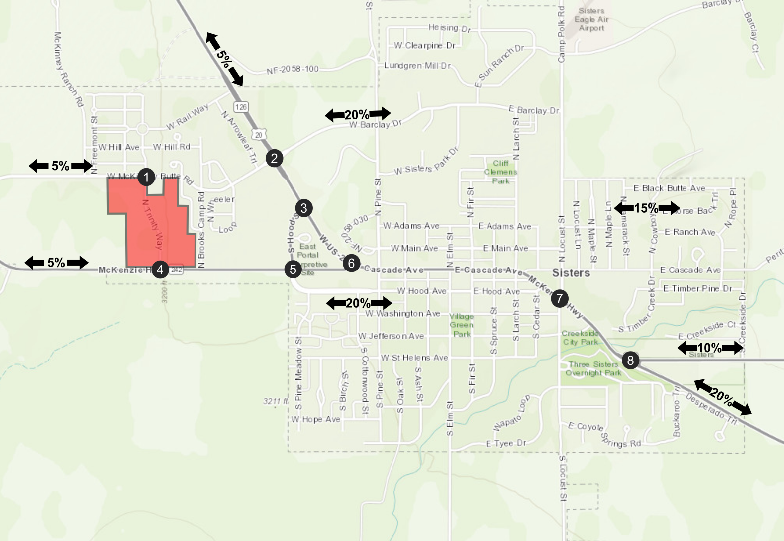
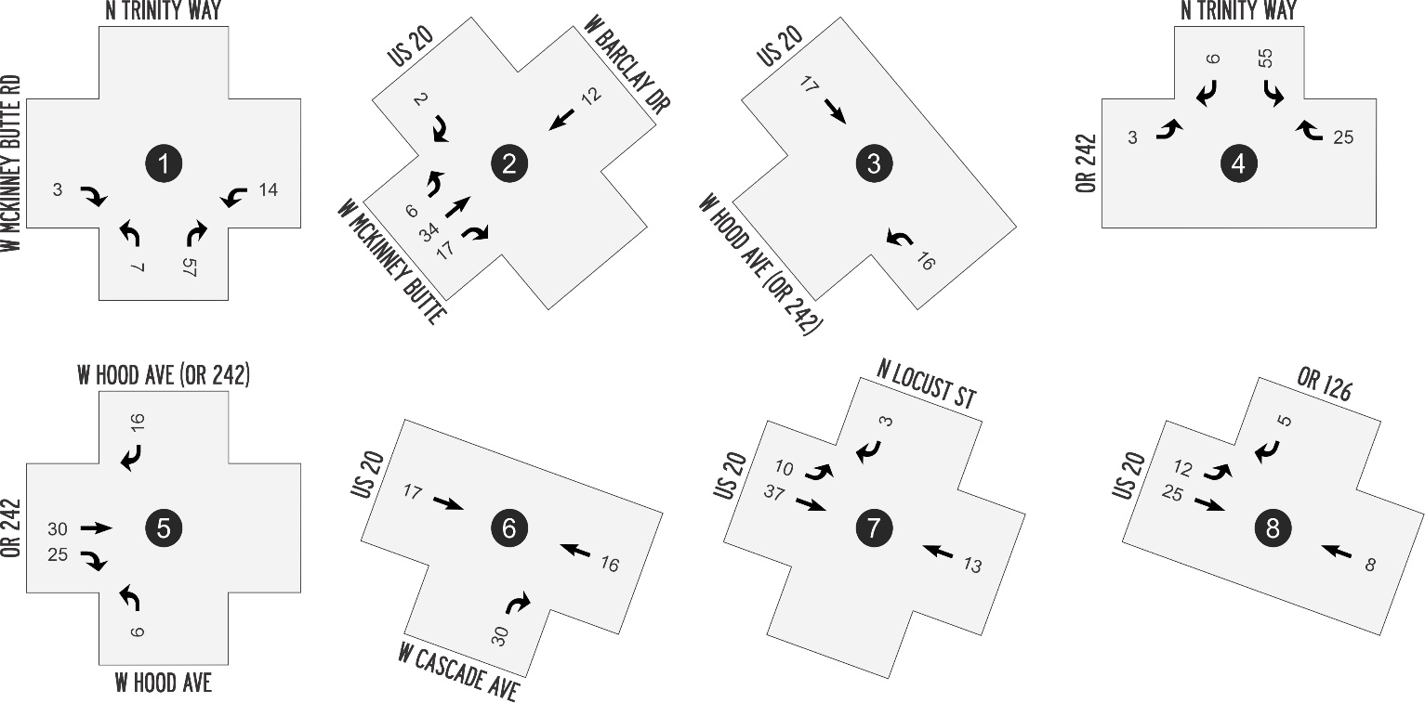
Figure 2. Estimated Trip Distribution and Trip Assignment of Additional Weekday PM Peak Hour Trips.

Study Area
ODOT considers projects as having a significant impact with 50 or more weekday p.m. peak hour trips at an intersection. Based on the estimated impacts shown in Figure 2, all of the locations shown in Figure 2 are included within this TPR analysis.

Traffic Volume Scenarios
Traffic volume scenarios were developed for the existing (UAR zoning) and proposed (PF/I and MFR) zoning scenarios using the forecast traffic volumes from the City’s Transportation System Plan Update as a base. These year 2040 forecasts directly reflect conditions with the existing zoning, with the proposed zoning scenario approximated through the addition of these volumes with the potential trip difference. The City’s TSP Update included all the study intersections except the Trinity Way connection to OR 242. Volumes at this location were approximated by balancing travel forecasts at the adjacent intersections. The resultant traffic volumes for the existing and proposed zoning scenarios are illustrated in Figures 3 and 4.

Traffic Operations
An operations analysis was prepared for the base and “with rezone” traffic volumes to identify whether there were any transportation facilities would require improvements to mitigate the impact of the proposed rezone. The operations analysis was prepared using the same analysis methodology (Highway Capacity Manual, 6th Edition) as the adopted Transportation System Plan. This analysis includes the planned roundabout at the US 20/Locust Street intersection and some level of rerouting associated with the full implementation of the Alternate Route.
Consistent with the adopted TSP, the comparative analysis, which is based on peak 15-minute summer conditions in 2040, identified the following:
- There is adequate capacity on the local City network to support the additional trips. Trinity Way, McKinney Butte Road, Hood Street, and Oregon Highway 242 will continue to operate within their carrying capacity.
- Even with the roundabouts, the US 20/Barclay and US 20/Locust intersections will operate over ODOT mobility standards with or without the rezone. To maintain acceptable mobility standards during the peak summer season, additional turn lanes would be required.
- Left-turns onto the highway will operate with high delays throughout the US 20 corridor. Development of off-highway routes to the roundabouts at McKinney Butte – Barclay and Locust Street will be important for continued highway crossings and access.
Additional details on the specific highway intersections are provided below.

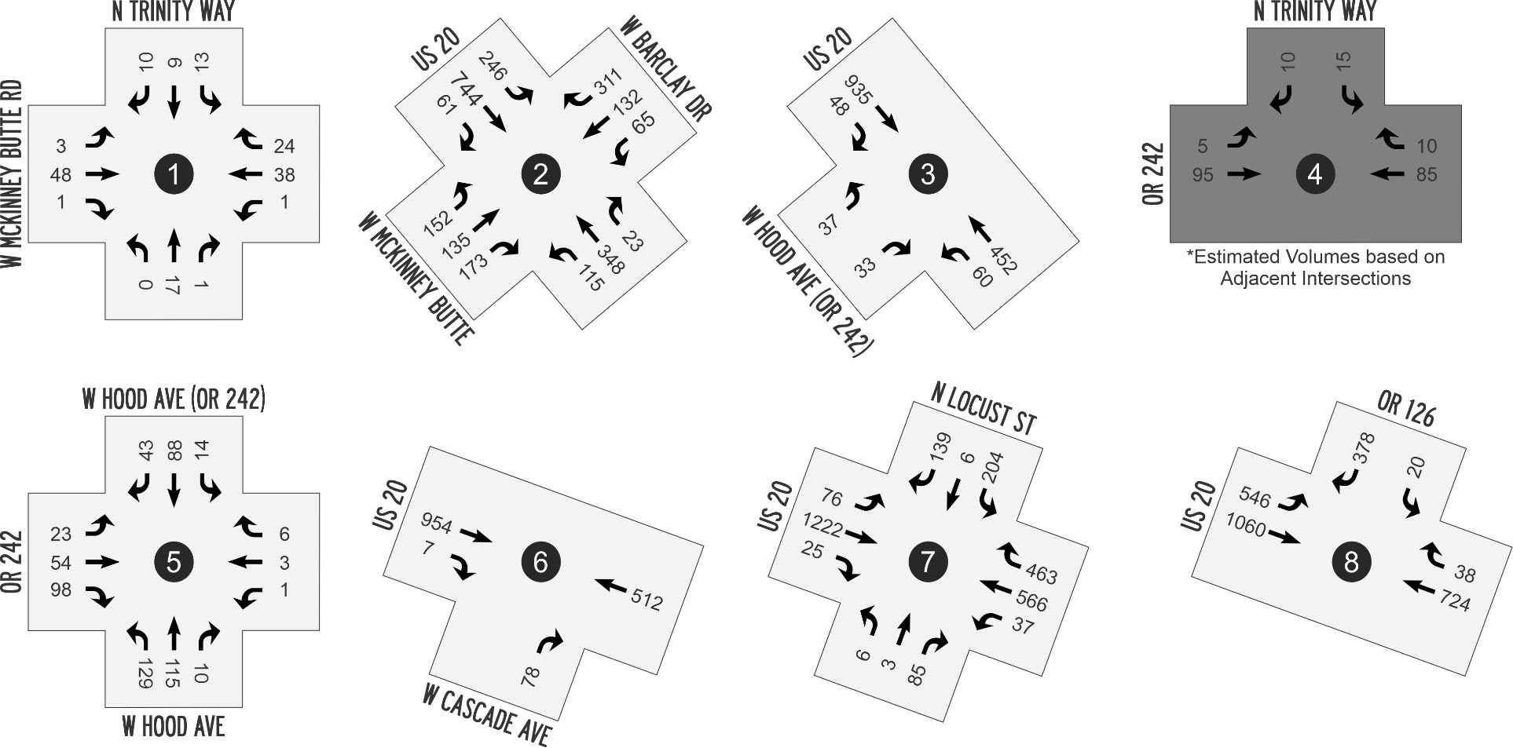
Figure 3. Year 2040 (Existing Zoning) traffic volume forecasts, weekday p.m. peak hour.
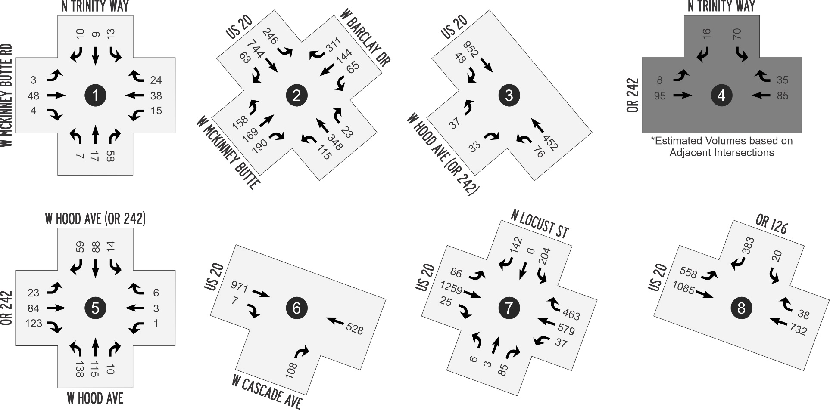
Figure 4. Year 2040 (Proposed Zoning) traffic volume forecasts, weekday p.m. peak hour.

Table 6. Summary of Intersection Operations, Weekday PM Peak Hour
Intersection | Performance Standard | Year 2040 Existing Zoning |  |  | Year 2040 Proposed Zoning |  |  | Acceptable?
 |  | LOS | Delay (s/veh) | v/c Ratio | LOS | Delay (s/veh) | v/c Ratio
1: N Trinity Way /  W McKinney Butte Rd | LOS D | NB LTR: LOS A  SB LTR: LOS A | NB LTR: 9.9  SB LTR: 9.5 | NB LTR: 0.03  SB LTR: 0.05 | NB LTR: LOS A  SB LTR: LOS B | NB LTR: 9.5  SB LTR: 10.0 | NB LTR: 0.12  SB LTR: 0.05 | Yes
2: US 20 /  W McKinney Butte –  W Barclay Dr¹ | v/c ≤ 0.80 | LOS F  EB LTR: LOS F  WB LTR: LOS E  NB LTR: LOS C  SB LTR: LOS F | 100.3  EB LTR: 175.4  WB LTR: 36.1  NB LTR: 22.2  SB LTR: 134.5 | EB LTR: 1.29  WB LTR: 0.87  NB LTR: 0.75  SB LTR: 1.24 | LOS F  EB LTR: LOS F  WB LTR: LOS E  NB LTR: LOS D  SB LTR: LOS F | 119.6  EB LTR: 239.9  WB LTR: 40.2  NB LTR: 25.7  SB LTR: 143.0 | EB LTR: 1.44  WB LTR: 0.90  NB LTR: 0.79  SB LTR: 1.26 | No
3: US 20 /  W Hood Ave² | v/c ≤ 0.85 | EB L: LOS F  EB R: LOS C | EB L: 58.2  EB R: 18.9 | EB L: 0.37  EB R: 0.12 | EB L: LOS F  EB R: LOS C | EB L: 68.1  EB R: 19.3 | EB L: 0.41  EB R: 0.12 | Yes
4: OR 242 /  N Trinity Way | v/c ≤ 0.90 | SB: LOS A | SB: 9.4 | SB: 0.03 | SB: LOS B | SB: 10.2 | SB: 0.12 | Yes
5: W Hood Ave /  OR 242 – W Cascade Ave | v/c ≤ 0.90 | LOS A | 9.3 | n/a | LOS B | 10.1 | n/a | Yes
6: US 20 /  W Cascade Avenue | v/c ≤ 0.85 | EB R: LOS C | EB R: 21.8 | EB R: 0.28 | EB R: LOS D | EB R: 25.4 | EB R: 0.40 | Yes
7: S Locust St /  US 20 (Roundabout) | v/c ≤ 0.85 | LOS F  EB LTR: LOS F  WB LTR: LOS D  NB LTR: LOS C  SB LTR: LOS B | 89.9  EB LTR: 165.3  WB LTR: 27.4  NB LTR: 22.0  SB LTR: 12.9 | EB LTR: 1.32  WB LTR: 0.91  NB LTR: 0.36  SB LTR: 0.51 | LOS F  EB LTR: LOS F  WB LTR: LOS D  NB LTR: LOS C  SB LTR: LOS B | 101.6  EB LTR: 185.4  WB LTR: 30.7  NB LTR: 23.8  SB LTR: 13.4 | EB LTR: 1.37  WB LTR: 0.93  NB LTR: 0.37  SB LTR: 0.52 | No
8: US 20 /  OR 126 | v/c ≤ 0.85 | EB L: LOS C | EB L: 16.4 | EB L: 0.65 | EB L: LOS C | EB L: 17.0 | EB L: 0.67 | Yes
¹ Note that US 20 Eastbound is referred to as “Southbound” at the US 20/Barclay Dr intersection.
² Note that US 20 Eastbound is referred to as “Southbound” at the US 20/Hood Ave intersection.

Additional details on the two “Alternate Route” roundabouts that were identified as exceeding ODOT mobility standards are provided below.

US 20/Barclay Drive – McKinney Butte Road Roundabout
The US 20/Barclay Drive intersection was reconstructed as a roundabout in 2017. When the analysis was originally prepared it was recognized that a multilane design would be needed at some future point. The decision to construct a single-lane roundabout considered long-term travel demands on the highway, and while recognizing the multilane needs balanced this with the safety and freight benefits that a single-lane design provided.
The single-lane roundabout was identified as operating over its summertime mobility target within the existing conditions analysis within the City’s adopted Transportation System Plan, operating around 90% of its carrying capacity. The roundabout exceeds a volume-to-capacity ratio of 1.0 in the future with or without the rezone.
The primary conflict at the roundabout is created by increasing demands for southbound through trips from Salem traveling directly through Sisters during the peak period. This summertime highway demand is largely attributed to these regional trips to Central Oregon from areas in the valley, whether for work or recreation. While the Alternate Route can help reduce the volume of these trips to a manageable level through downtown Sisters, the left-turn maneuver to use the Alternate Route provides a high strain on each of the approaches. The most beneficial treatment is a dedicated left-turn lane from Eastbound US 20 onto the Alternate Route (and a dedicated westbound right-turn from Barclay onto westbound US 20), which would increasingly reduce traffic through the downtown core. Preserving additional right-in, right-out connections onto US 20 will be helpful in avoiding the consolidation of all traffic at the roundabout, as the McKinney Butte Drive approach cannot adequately serve the City demands without these additional outlets.
The rezone does not change the long-term transportation needs within this area. As a legislative rezone the location of these residential and employment lands near schools, retail, and residential uses, and interconnected with pathways and sidewalks, provides an ideal location for urban lands that will support the complete community in west Sisters.

US 20/Locust Street Roundabout
The City’s adopted Transportation System Plan shows that a single-lane roundabout at the US 20/Locust Street intersection can support the City’s growth through about 2030. Beyond that timeframe, either additional auxiliary lanes, parallel route enhancements, or other similar improvements will be needed to serve peak summertime demands. The project list within the TSP identifies the long-term plan at US 20/Locust Street as the “construction of a single-lane roundabout with future expansion provisions”.
ODOT has completed a feasibility study and is finalizing design plans for the single-lane roundabout, which has funding secured for the 2024 through 2027 Statewide Transportation Improvement Program (STIP), with construction anticipated in spring 2024 (see Figure 5). Similar to the roundabout at Barclay Drive, this roundabout will contain oversized freight accommodations allowing large trucks to utilize the Alternate Route as a means of traveling west of the City.
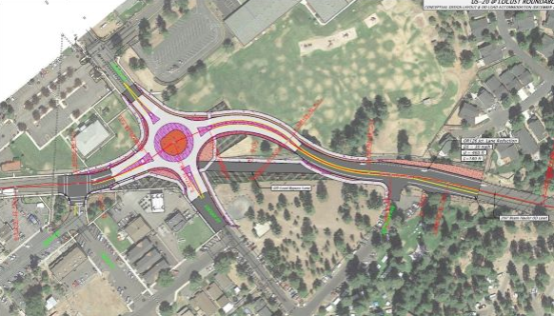
Figure 5. Conceptual US 20/Locust Street roundabout. Source: Oregon.gov/odot/projects/
The year 2040 traffic forecasts show that this new roundabout will experience the highest delays on the eastbound approach, with over 1,200 peak hour trips heading through the intersection toward Redmond and Bend during the summertime commute period. These forecasts show reserve capacity remains on the northbound and southbound approaches.
With the traffic patterns it is expected that use of the Alternate Route would increase, reducing through volumes on the highway as motorists seek to balance overall travel times and delays. It is likely that the volume shift would occur both north and south of US 20, with an additional 250 vehicles using the Alternate Route and 200 vehicles using Washington and Jefferson Avenue to access eastbound US 20. While these diversions are not adequate to fully mitigate the roundabout, addition of a dedicated westbound right-turn lane and/or southbound left-turn lane would be the most beneficial expansion options, as these treatments would further prioritize the Alternate Route. While the westbound right-turn lane would not address the critical eastbound maneuver it would substantially reduces queuing and allow vehicles to directly access the Alternate Route. The dedicated southbound left-turn lane would be more beneficial, but results in a multi-lane roundabout design with side-by-side maneuvers, which has the potential of reducing the overall safety at the roundabout.
Improvement needs at the roundabout are identical with or without the rezone. Effectively, there are no changes to the required Transportation System Plan associated with this rezone. The addition of additional urban lands support a higher accommodation of population/employment within City boundaries, and provides housing within immediate proximity of the City’s elementary, middle, and high school, groceries, and with access to pathways and walkways that extend directly into the downtown core area. Accordingly, for a legislative rezone process these lands are located in an area with the potential to generate a comparatively low vehicle-miles travelled.

Transportation Planning Rule Compliance
As shown within these transportation materials, the proposed legislative rezoning of the subject properties to PF/I and MFR does not alter the long-term plans or needs identified within the City’s Transportation System Plan. There are impacts shown to the US 20 Alternate Route roundabouts at Barclay Drive and Locust Street, but the mitigation measures previously identified within the TSP remain the same with or without the rezone. While the proposed rezone follows a legislative process, for consistency with prior area rezones, the following mitigation measure is provided to ensure that adequate funding mechanisms are in place to support the City’s long-term needs, particularly as the future expansion of the roundabouts is not a funded project and would not be considered “reasonably likely”.
A pro-rata payment shall be provided toward improvements along US 20 and the parallel Alternate Route to support east-west mobility needs along the US 20 corridor. Improvements to either facility is considered adequate mitigation for the finding of a significant impact based on OAR 660-12-0060(2)(e):
(e) Providing improvements that would benefit modes other than the significantly affected mode, improvements to facilities other than the significantly affected facility, or improvements at other locations, if:
(A) The provider of the significantly affected facility provides a written statement that the system-wide benefits are sufficient to balance the significant effect, even though the improvements would not result in consistency for all performance standards;
(B) The providers of facilities being improved at other locations provide written statements of approval; and
(C) The local jurisdictions where facilities are being improved provide written statements of approval.
The specific improvements that were previously identified by the City and ODOT to enhance the Alternate Route include the following; note that specific addition of auxiliary turn lanes at the roundabout are not included within these interim measures:
- Variable Message Signs for eastbound and westbound US 20 traffic (Est. $400,000 with overhead mount, cabinet, and wireless communication system).
- Alternate Route Wayfinding Signage (Est. $10,000 with fabrication/installation)
- Completion of single-lane US 20/Locust roundabout (fully funded by the STIP)
- Completion of Barclay/Locust roundabout (50% costs from SDC, 50% unfunded - $1,250,000)
Total Unfunded Projects: $1,660,000
Estimated Pro-Rata Impact to US 20: 63 Added Highway PM Trips / 1,498 Through Trips = 4.21%
Based on a total improvement cost of $1,660,000, this percentage results in a total contribution from the collective properties of $69,813, and based on a total trip generation potential of up to 255 weekday p.m. peak hour trips equates to $274 per PM Peak Hour Trip.
These contributions would be supplemental to City SDC fees, and could be paid as part of any future site plan entitlements for the affected properties, with the fee assessment based on the current edition of the ITE Trip Generation Manual at time of site plan application.

Next Steps
I trust that these transportation materials adequately address the impacts of the proposed City-led (legislative) zone change and text amendment within western Sisters, allowing the impacted parcels to be rezoned from Urban Area Reserve to a combination of Public Facilities/Institutional and Multifamily Residential. Please let me know if you have any questions on these materials at joe@transightconsulting.com or at (503) 997-4473.

Attachments:
- Year 2040 Existing Zoning LOS Worksheets
- Year 2040 Proposed Zoning LOS Worksheets
- Year 2040 Existing Zoning LOS Worksheets with Auxiliary Turn Lanes
- Year 2040 Proposed Zoning LOS Worksheets with Auxiliary Turn Lanes

Based on projected 2040 highway through trips at US 20/Pine Street as identified within prior US 20 forecasts used to establish this methodology (868 eastbound, 630 westbound).

